Ideation Phase Brainstorm &amp; Idea Prioritization Template
Date | 24 September 2026
Team ID | SWTID-2026-6228
Project Name | AI BlogNest API
Maximum Mark | 4 Marks

Brainstorm &amp; Idea Prioritization Template:
Brainstorming is a creative process that gives team members the freedom to share their thoughts and ideas openly. It helps everyone work together to identify problems and find possible solutions.
During brainstorming, the main focus is on generating a large number of ideas rather than immediately judging their quality. New, unusual, and creative ideas are encouraged. Team members can also develop and improve each other’s suggestions.
Use this template to organize your brainstorming activities, encourage creativity, and turn new ideas into useful concepts, whether your team is working together in person or from different locations.
Step-1: Team Gathering, Collaboration and Select the Problem Statement
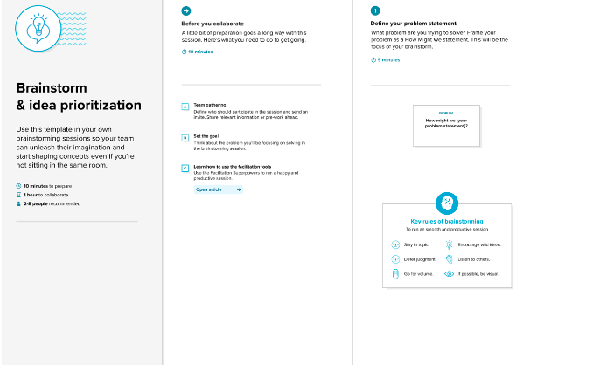Step-2: Brainstorm, Idea Listing and Grouping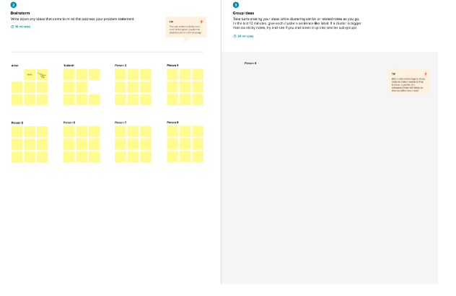Step-3: Idea Prioritization
